IP WAN Networks

Basic Characteristics
• Because of the great growth of the Internet popularity, practically every WAN must be capable of transmitting IP traffic. This means that nearly (neredeyse) all contemporary (modern) WANs are based on IP and all differences among them consist of the technologies bellow the IP layer.
• In the mid-1990s, the multilayer structure of the IP WAN became the most popular. In such WANs, ATM and Frame Relay networks are used as constituent (kurucu) networks. Using packet-switched networks based on different principles (datagram service and virtual channel service) at both layers makes IP WANs complicated and expensive. However, these drawbacks are compensated (karsilanmak, telafi edilmek) by the possibilities of transmitting multimedia information and using QoS and traffic engineering methods to balance (dengelemek) loads and optimize network resource use.
• IP WANs in which IP routers are directly connected by physical point-to-point links have the simplest structure. Such networks are called “pure” IP WAN networks because there is no layer of packet switches bellow the layer formed by IP routers. This means that IP routers carry out all tasks related to (ile ilgili) packet forwarding on their own.
• The Multiprotocol Label Switching (MPLS) technology is another innovation (yenilik) in the field of integrating IP with virtual channel technology. MPLS takes an intermediate position between the IP layer and the data link layer, thus integrating them into the unified (birlesik), more efficient structure.

IP WAN Structure
• To provide a range (dizi) of high-quality services, many large WANs, especially those owned by commercial (ticari) communications carriers, are built according to a four layer design.
• The two lower layers do not relate to packet switched networks. At the lowest layer of the transport network, the DWDM technology which nowadays is the fastest is employed. It creates spectral channel ensuring transmission speeds of 10 Gbit/s or greater.
• SDH technology (with the PDH access network) operates at the next layer. Using this technology, the bandwidth of these spectral channels is divided into TDM subchannels connecting the interfaces of the switches of the packet-switched networks (or telephone exchanges).
• On the basis of a transport network every communications carrier can quickly organize a permanent digital link between the connection points of the overlay network equipment, either telephone or packet switched.
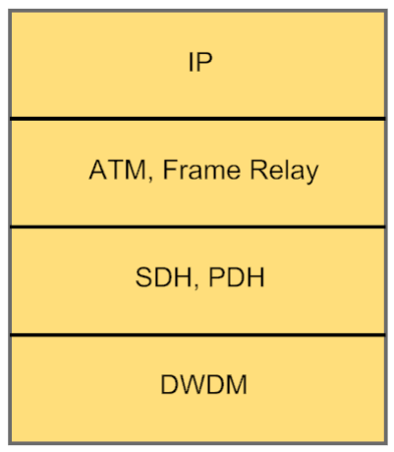
Multilayer structure of IP WANs

• In simpler cases, there is no transport network at all (hic), and below the IP layer, there can be ATM or Frame Relay network. Such solution is cheaper but less flexible.
• The ATM network, whose main goal is the creation of a permanent virtual circuit (PVC) infrastructure with guaranteed QoS, forms the third layer. The PVCs created by the ATM network connect the interfaces of IP routers. For each class of IP traffic, the ATM network forms a separate virtual circuit, which ensures the QoS parameters required for serving this traffic class – average bit rate, burst size, delay and loss level. Using ATM as underlying technology for IP not only offers required QoS for user traffic but also ensures a balanced (dengeli) load for all physical links of the transport network.
• The higher layer in the WAN model is formed by an IP network. The IP layer carries out its typical functions – namely (yani, soyleki), it builds an internetwork and provides IP services to end users.
• Despite the complications of the multilayer structure, such networks have become widespread (yaygin), especially in networks of large communications carriers and service providers. Using this standard, they can provide complex services such as IP services, ATM services, classical telephony services and digital link leases (kiralama).

Pure IP WANs
• For a long time IP networks did not have such a complicated multilayer structure. A classical IP network consisted of routers directly connected by communication links. Such network did not provide QoS support because at this time the applications generated (uretmek) traffic that was not sensitive to delays. After arrival of multilayered IP WANs, it became necessary to distinguish (ayirmak) these two types of networks. Therefore, classical IP networks were called “pure” IP WAN networks.
• If the IP router uses channels created within the SONET network, this variant is called Packet over SONET (POS).

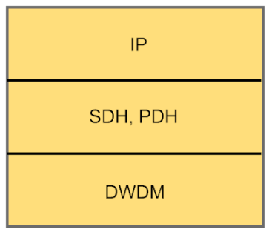
Structure of pure IP WANs
• Pure IP networks can be successfully used for transmitting delay sensitive traffic in the following cases:
- The IP network operates in the underloaded mode (dusuk yuklu mod). Therefore, services of all types are oversubscribed (fazla ilgi gormus) and do not need to wait in queues. The network, consequently (bu nedenle, sonuc olarak), does not require QoS support.
- The IP layer ensures QoS support on its own (kendi basina) by using IntServ (Integrated Services) or DiffServ (Differentiated Services).
• For IP routers in the pure IP WAN model in order to use digital links, some data link layer protocols must operate on these links (e.g. HDLC protocol, PPP, SLIP). These protocols have procedures for operation in WANs built-in (yerlesik), including:
- data flow management,
- mutual (karsilikli) authentication for remote (uzak) devices,
- coordination of the data exchange parameters at the data link and physical layers (e.g. maximum size of the data field – MTU).
• Besides the protocols developed for point-to-point WAN connections, the high speed Ethernet can be used – Fast Ethernet, Gigabit Ethernet or 10 Gigabit Ethernet.

HDLC Protocol
• High-level Data Link Control (HDLC) is the family of protocols that create data link layers for the following networks:
- LAP-B for X.25 networks,
- LAP-D for ISDN networks,
- LAP-F for Frame Relay networks,
- LAP-M for asynchronous and synchronous modems.
• HDLC can operate in several modes and supports both point-to-point and point-to-multipoint connections.
PPP Protocol
• Point-to-Point Protocol (PPP) is the Internet standard. Similar to HDLC, it also represents the entire family of protocols:
- Link Control Protocol (LCP),
- Network Control Protocol (NCP),
- Multi Link PPP (MLPPP),
- Password Authentication Protocol (PAP),
- Challenge Handshake Authentication Protocol (CHAP).
• The main difference between PPP and other data link layer protocols is that it achieves coordinated (es gudumlu) operation of different devices by using a special negotiation (muzakere, gorusme) procedure. During this procedure, the devices exchange various parameters, such as line quality, an authentication protocol, and encapsulated network layer protocols.

Leased Lines Used in IP WANs
• To connect the router port to the leased line, it is necessary to use the appropriate (uygun) type of Data Circuitterminating Equipment (DCE) device. This device is required for transforming a router’s physical interface to the physical layer protocol used by a leased line. If the leased line is an analog line, then it is necessary to use a modem as DCE device. In the case of a digital line the Channel Service Unit / Data Service Unit (CSU/DSU) device must be used.
• The router’s port may include a built-in DCE device. For example, when the router uses a SDH channel, it usually has a built-in port with a SDH interface for a specific STMN rate.
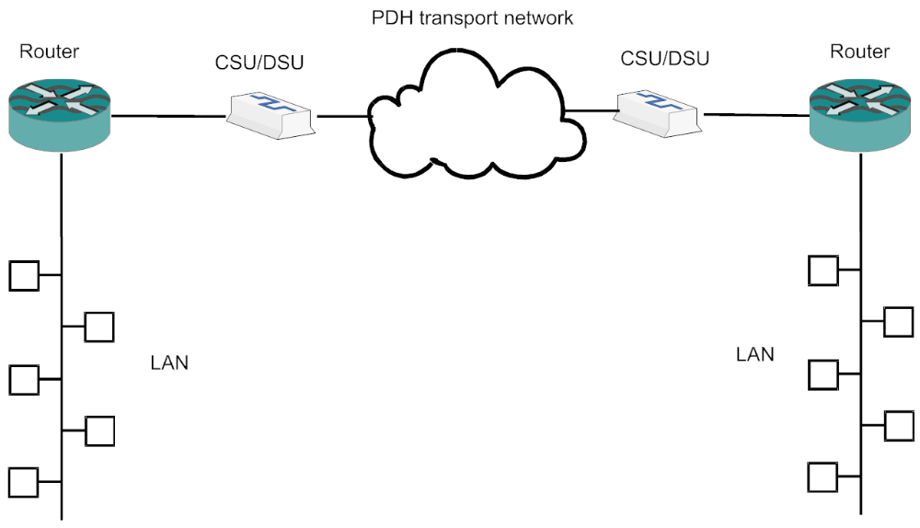
Connecting IP networks using a leased line
Multiprotocol Label Switching (MPLS)
• MPLS combines the virtual channel technique with the TCP/IP stack functionality. This combination is achieved because the same network device, the Label Switch Router (LSR), simultaneously (ayni anda) plays the role of a classical IP router and a virtual channel switch. However, this is not a mechanical combination of two devices. It is a close integration in which the functions of both devices are used together and complement (tamamlamak, tamamlayici) each other mutually (karsilikli olarak).
• Multiprotocol support in MPLS consists of the fact that it can not only use TCP/IP routing protocols but also routing protocols of any other stack, such as IPX/SPX.
• MPLS uses routing protocols to discover (kesfetmek) network topology. It also uses the virtual channel technique to forward data within the limits of the MPLS network of a single provider.
• The principle of combining the protocols of different technologies is illustrated (gosterilmek) in figures (resimler). The first illustration shows the simplified architecture of a standard IP router and the second one shows the architecture of a combined LSR device supporting the MPLS technology. Because the LSR carries out all functions of the IP router, it includes all its units. To support MPLS functions, the LSR also includes the range of auxiliary units related to control plane and data plane functions.
• The label forwarding unit transmits IP packets on the basis of a label instead of the destination IP address.
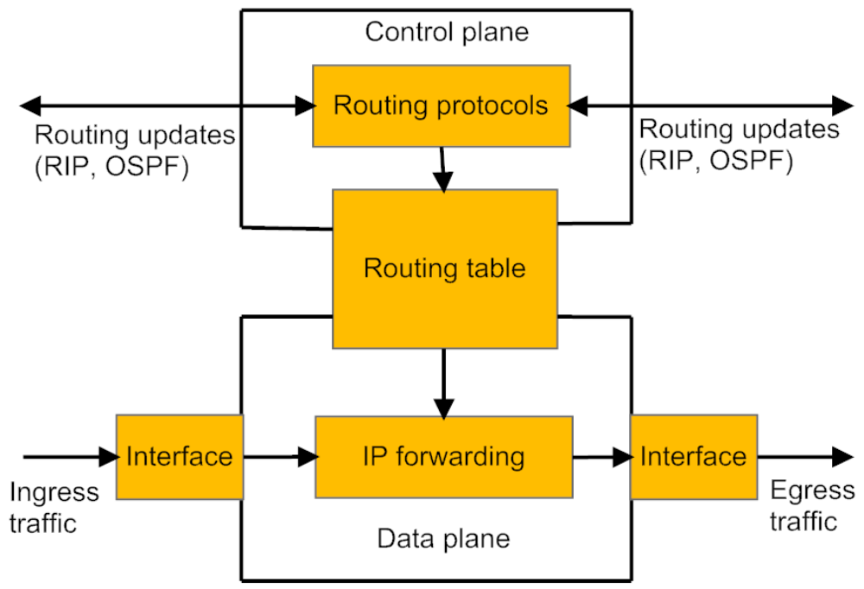
IP router architecture
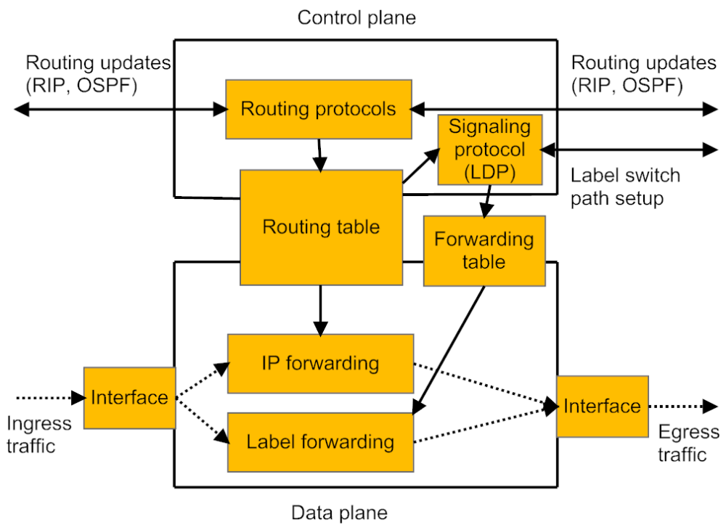
LSR architecture
• When making a decision about the next hop (sonraki durak), the label forwarding unit uses the forwarding table which is similar to the forwarding tables of other technologies based on the virtual channel technique.
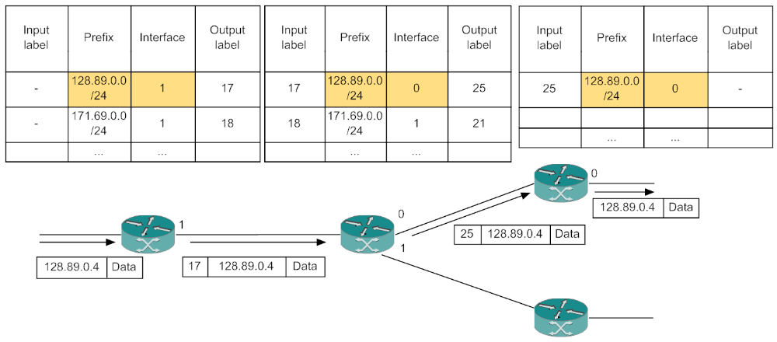
Label switching using forwarding table
• MPLS forwarding tables for each LSR are formed using the signaling protocol which is known in MPLS under the name Label Distribution Protocol (LDP). This signaling protocol is functionally similar to the ATM and Frame Relay signaling protocols.
• By creating forwarding tables on LSRs, LDP establishes virtual path which is known as Label Switch Path (LSP) in the MPLS technology.
• An edge (kenar) LSR in the MPLS technology is also called a Label switch Edge Router (LER).
• An LER accepts traffic from other networks in the form of standard IP packets, supplies this traffic with labels and sends it along the corresponding (ilgili) LSP to another LER. Every intermediate LSR forwards the packet on the basis of its label instead of the destination IP address.
Like other virtual channel technologies, the label has a local value within the limits of each LSR. When the packet is passed from the input interface to the output interface, the label changes its value. The output (egress (cikis) ) LER removes the label from the IP packet and passes it to the next network in a standard form. Thus, the operation of the MPLS technology remains (kalmak) invisible (gorunmez) to all other IP networks.
• An LSP is unidirectional (tek yonlu) virtual channel. Therefore, to transmit traffic between two LERs, it is necessary to establish at least two LSPs, one in each direction.
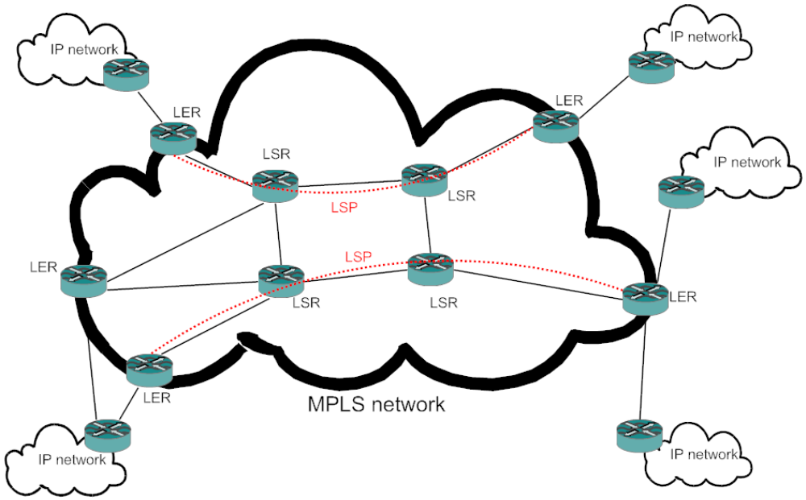
MPLS network

MPLS Header
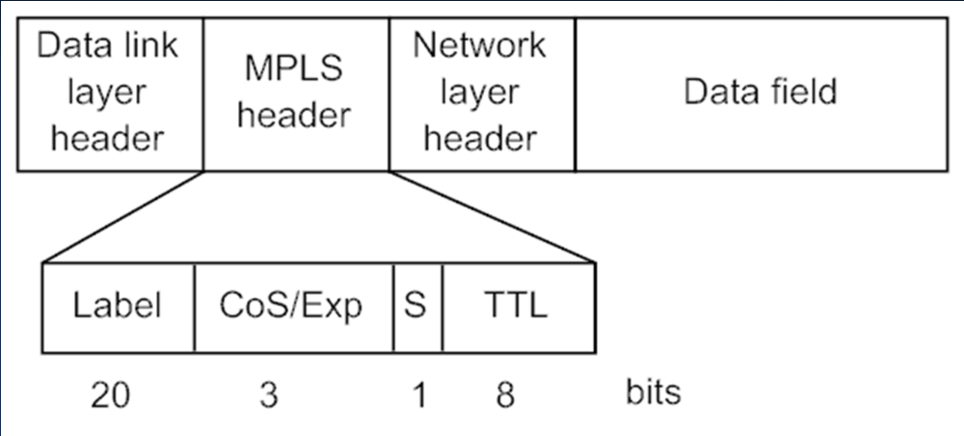

• Label – is used for choosing the corresponding (ilgili) LSP.
• Class of Service (Hizmet) (CoS)/Experimental (Deneysel) – was reserved for future use. More recently (daha yakin zamanlarda), it has been used mainly (baslica) for specifying the class of traffic that requires a specific level of QoS.
• S – is the indicator of the bottom of the label stack.
• Time to live (Canli kalma suresi) (TTL) – has the same function as the similar field from the IP packet header.
• Ethernet, PPP, Frame Relay or ATM can be used as a data link layer technology.
• Using ATM, the label is placed into the VPI/VCI field of the ATM cell header. The remaining (kalan) part of the MPLS header is stored in the data field of the ATM cell.

MPLS Application Areas
• MPLS IGP (MPLS Interior (Ic) Gateway Protocol) - MPLS is used only for accelerated (hizlandirilmis) network-layer packet forwarding, which is caused (kaynaklanmak) by reducing the size of routing tables because, as a rule, routing tables contain more records than forwarding tables. The process of routing is also longer than the process of switching. This difference is especially noticeable (goze carpan) for large backbones, where the routers may operate with routing tables containing tens of thousands of records. Using this application, packets travel along the routes chosen by a standard interior gateway protocol.
• MPLS TE (MPLS Traffic Engineering) – MPLS LSPs are chosen for solving traffic engineering problems on the basis of modified routing protocols. MPLS TE not only ensures a rational (rasyonel, mantikli) and balanced load on all resources of the provider’s network but it also creates a solid (saglam) foundation for providing transport services with guaranteed QoS parameters.
• MPLS VPN (MPLS Virtual Private Network) – This area of MPLS application allows the provider to offer VPN services on the basis of traffic segregation (ayrim) without mandatory (zorunlu) data encryption (sifreleme).
• AToM (Any Transport over MPLS) – AToM enables the transmission of data link layer frames over the MPLS network while retaining (tutma, saklama) all information in their headers. In the data field of the MPLS packet, there can be the Ethernet frame, Frame Relay frame, PPP frame, ATM cell, etc.
• VPLS (Virtual Private LAN Service) – VPLS is similar to the AToM technology. It enables the transmission of the Ethernet frames over the MPLS network by creating not only point-to-point but also point-to-multipoint connections. VPLS network emulates (taklit etmek) the behavior of the Ethernet frames switch (including creating of the MAC address table).
• All these types of MPLS applications can be used within the same network, providing users with combined services.

